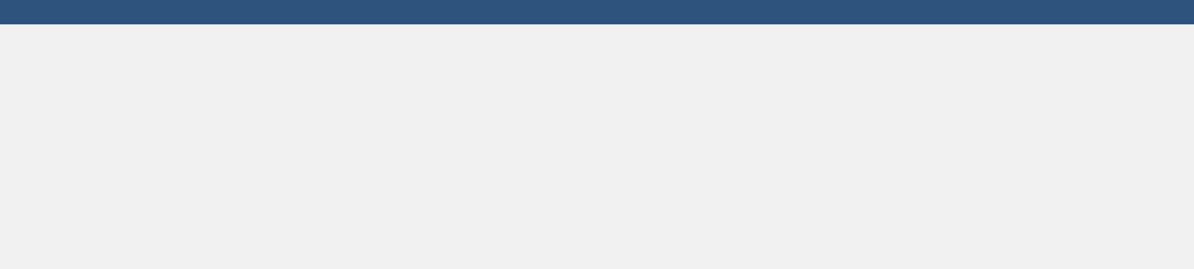

HUMAN RESOURCES COVER LETTER

your.name@gmail.com | (XXX) XXX-XXXX | 142 Your Address Blvd, City Name, CA XXXXX

[Today’s Date]

[Hiring Manager’s Name]

[341 Company Address]

[Company City, State xxxxx]

[(xxx) xxx-xxxx]

[hiring.manager@gmail.com]

Dear [Mr./Mrs./Ms.] [Manager’s Name],

I’m contacting you regarding your advertisement for the Human Resources opening listed on your website. My interest in this position stems from my belief that I have the right combination of relevant staffing experience, communication skills, and high levels of organization that make me a superb candidate.

To date I feel my strongest abilities are:

• Increasing employee retention by rigorously maintaining a positive work environment

• Developing targeted outreach recruitment programs to recruit the best talent and meet all departmental hiring requirements

• Creating user-friendly application forms and questionnaires to be used by the organization during staff recruitment and interviewing

• Arbitrating labor disputes in collaboration with the legal department

I consider myself to be a dedicated and dependable individual who possesses excellent verbal and written communication skills. I feel that a relationship with your company would be mutually beneficial, as my educational background, HR experience, and qualifications would make me a perfect fit for your Human Resources position. This opportunity would also allow me to refine my skills in a new working environment.

In closing, I would like to thank you for your time and attention, and I hope to have the chance to discuss the opening with you in person.

Sincerely,

[Your Name]

